Data Flow Diagrams and User Stories
Project: Emotion-Aware Personalized Learning Platform

Data Flow Diagrams:
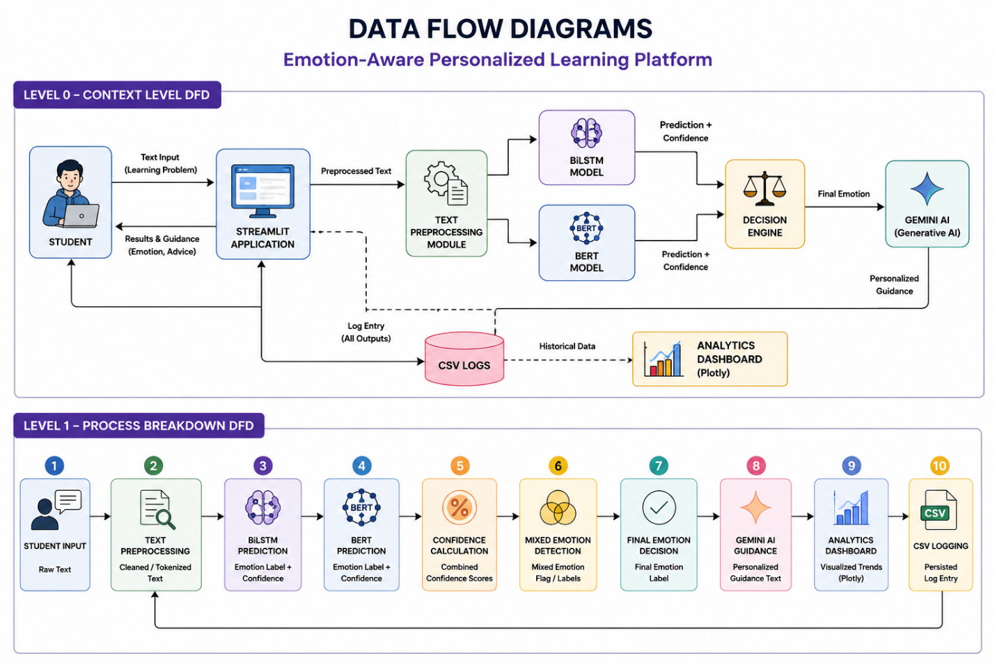

2. Data Flow (Level 1 — Process Breakdown)
Step | Process | Input | Output
1 | Student Input | Raw text | Raw student query
2 | Text Preprocessing | Raw text | Cleaned/tokenized text
3 | BiLSTM Prediction | Cleaned text | Emotion label + confidence
4 | BERT Prediction | Cleaned text | Emotion label + confidence
5 | Confidence Calculation | Both model outputs | Combined confidence scores
6 | Mixed Emotion Detection | Combined confidence scores | Mixed emotion flag/labels
7 | Final Emotion Decision | Model outputs + mixed emotion flag | Final emotion label
8 | Gemini AI Guidance | Final emotion label | Personalized guidance text
9 | Analytics Dashboard | Historical CSV logs | Visualized trends (Plotly)
10 | CSV Logging | All above outputs | Persisted log entry

3. User Stories
ID | As a… | I want to… | So that…
US-1 | Student | enter my learning problem as free text | the system can understand how I feel about it
US-2 | Student | see my detected emotion (e.g., Confused, Bored) | I can understand my own learning state
US-3 | Student | see confidence scores from both models | I can trust the reliability of the prediction
US-4 | Student | receive personalized guidance from Gemini AI | I get relevant help based on how I feel, not generic advice
US-5 | Student | see when I have mixed emotions (e.g., Curious + Confused) | I get a more nuanced understanding of my state
Us-6 | view an analytics dashboard | I can see emotion trends across sessions
US-7 | System | log every interaction to CSV | historical data is available for analysis and future model improvement
US-8 | System | handle invalid input or API errors | the user experience remains smooth despite failures

